

**Finding a direction in your research**

* **Critical reading skills**
* **Efficient literature review**

**Developing a critical approach**

What resources do you use to stay on top of the recent developments in your field ?

1. Academic journals
2. Conferences
3. Forum/blogs
4. Popular computer science magazines
5. Course lectures and seminars

What was the last text you read related to your subject area?

Why did you read the text?

Did you read the whole text or just parts of it?

Did you skim the text or did you read it extensively?

Did you take notes, highlight sections or not write at all?

* When reading any type of text, it is crucial to be able to tell the difference between **facts and opinions**.

1. **Examine the examples below and then complete the information in the following table. You can decide that the statements are facts or opinions or both.**

|  |  |  |
| --- | --- | --- |
|  | Fact | Opinion |
| 1. The old computing was about hardware, the new computing is about users. |  |  |
| 2. In the context of human-computer interaction, the designation of a device as either output or input is a matter of perspective. |  |  |
| 3. Linux was originally aimed for computer enthusiasts, but nowadays it is widely used by popular commercial platforms and Linux distributions are dominant in the server and supercomputing sectors. |  |  |
| 4. As new technologies evolve, they become the new standard. |  |  |
| 5. Computation creates growing public discomfort. |  |  |
| 6. Artificial intelligence is a family of techniques where algorithms uncover or learn associations of predictive power from data. |  |  |
| 7. Some of the most vocal and active criticisms of software patentability lie within the Free and Open Source movements. |  |  |

1. **Complete the sentences below in your own words:**
2. If you read a research *critically*, it means that you…
3. You should always read a research *critically* because…

Now, consider the following questions:

How do you read a research?

How do you choose the sources for your research?

**Evaluating internet sources**

* Internet sources provide information in abundance, but we need to be careful before we can claim the material is trustworthy.

**1. Compile a number of questions we should ask about different sites when conducting a research**:

eg. A. Is the language used in a suitable academic style?

B. Does the evidence presented contradict my own experience and common sense?

**2. Read the following texts (A & B) and decide:**

* **where the extracts come from**
* **if you can trust the information provided in the texts**
* **which text you would consider for more extensive reading**

**Give reasons for your decision**.

Text A

New research published by the University of Surrey in Boston College Law Review is calling for inventions by computers to be legally granted patents. The research states that the rapid increase in computer power is posing new challenges when it comes to patenting an invention. Artificial intelligence is playing an ever larger role in innovation - with major players such as IBM, Pfizer and Google investing heavily in creative computing -- but current patent law does not recognise computers as inventors.

Without a change in the law, the findings warn that there will be less innovation, caused by uncertainty, which would prevent industry from capitalising on the huge potential of creative computers. We are also likely to see disputes over inventorship, with individuals taking credit for inventions that are not genuinely theirs.

Ryan Abbott, Professor of Law and Health Sciences at the University of Surrey's School of Law proposes that non-humans should be allowed to be named as inventors on patents as this would incentivise the creation of intellectual property by encouraging the development of creative computers. By assigning ownership of a computer's invention to a computer's owner, he argues, it would be possible to reward inventive activity which happens before the invention itself.

Text B

The increase in patents over the past two decades — in areas ranging from semiconductors and software to human gene sequences — has been well publicised and its sources and economic effects are widely discussed. The embracing of patenting by universities has also been a subject of debate, raising questions about the consequences of patenting on the progress of science and the advancement of technology. As technologies become more interdependent and innovation relies more and more on fragmented proprietary knowledge, concerns are emerging about innovation becoming more difficult and the commercialisation of technologies being held backed by patents. And yet, many patents correspond to a new wave of inventions (information and communication technology, biotechnology) and technological activities, which might have not appeared, or might have been delayed, without patent protection. For this reason, there is an imperative need to better understand the obstacles which patents might generate to the diffusion of technology, how they can be overcome, and how patents may be used in contracts to ensure fluidity in technology markets. We, therefore, need to discuss the multiples role played by patents in fostering innovation and the commercialisation of technology: how patents affect innovation incentives, the building of knowledge infrastructures and the development of technology markets. Lastly, we need to stress the need to collect and analyse new data in order to design evidence–based policies in this field.

**3. Look at the following diagrams and discuss what do you think it describes and what research topic it would be associated to?**

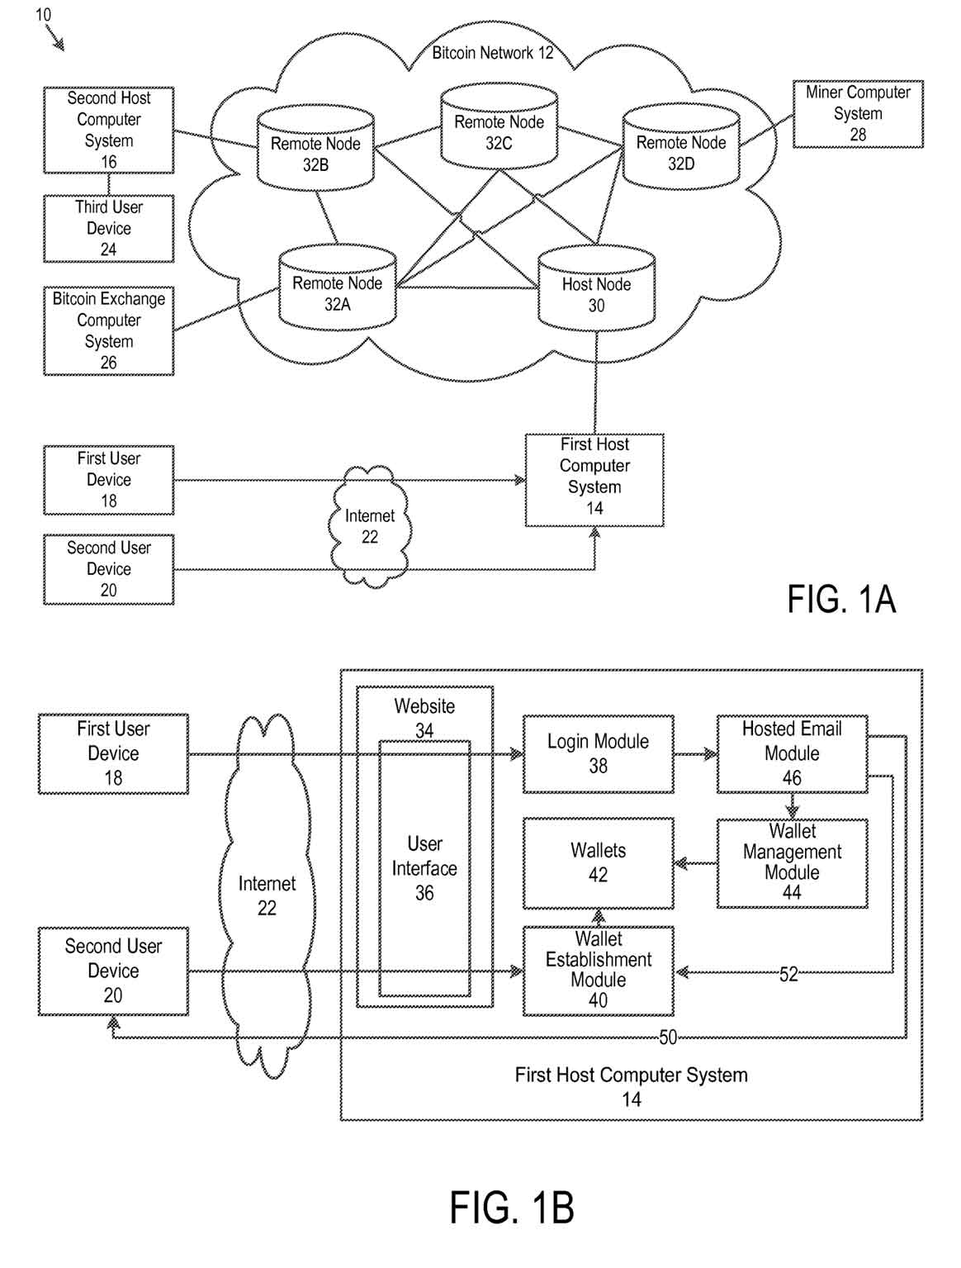

**Efficient reading**

Listening practice

1. You will listen to Andrew Ng, Stanford professor within the Department of Computer Science, founder of DeepLearning.AI and co-founder of Coursera, deliver a presentation on Scientific literature reading techniques. Take notes on the following topics and present them in class:

1. techniques to accelerate student efficiency in reading a new body of literature
2. guidelines for required volume of reading
3. guidelines for reading one research paper

Note: You will need to show your notes in class when you discuss the above-mentioned topics, so make sure they are clear and organized.

**You have decided to read up on the topic of software patentability to help plan a research on Computer Implemented Intervention (CII) patents.**

**Discuss the following suggestions of a step by step method for handling texts and compare them with the reading techniques discussed above:**

1. Why is it a good idea to review the literature before planning your research?
2. When you read an article, which of the following steps do you take and why?

* look at title and subtitle
* survey text for key features: abstract, contents, keywords, index
* skim text for general idea – is it relevant to your work?
* scan text for specific information you need
* read extensively large sections of a text
* read again to keep notes of main points

1. What is the next step after reading some of the literature?

Extension activity

**Let’s demonstrate how far you can get in understanding a research paper in just minutes.**

**Select one piece of published research paper in your field and answer the following questions:**

a. What did the author try to accomplish?

b. What were the key elements of the approach?

c. What can you use yourself?

d. What other references do you want to follow?

Note: Try to spend 1 minute/page and make sure the selected research paper is up to 7 pages long.